# 

# MEET Y1 - Unit 3 - Strings Lab Part 1

## Part 1 - Try it out!

1. Open  **IDLE3**. A window should pop up. (See below)

2. In the shell, type and hit enter.

What do you see?

3. Now type and hit enter.

Use double quotations " ", instead of single quotations ' '.

Did anything change?

4. Print Hello to your partner by including his/her name (for example,

"Hello Claire"). Show it to them!

5. Now type and hit enter.

What happens when you run the code?

You have just made a **comment**. **Python** does not read anything after the # symbol (but people looking at your code do).

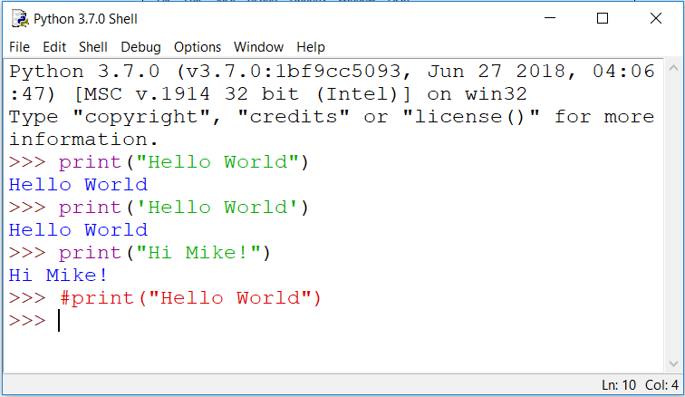

**If your code looks like this, move on. If not, ask your partner or an instructor for help!**

6. Open your terminal and type startlab. In the text editor that opens,

go to *File* → *New File* and then *File* → *Save As…*

Name your file Echo.py . Make sure you are not writing code in the shell!!!! There should be no “>>>” in this file.

7. Make a variable named *user* that takes input from the user. Like this:



8. Test your code! When you run your file **(Press *F5*)**  you should see something like this in the python shell: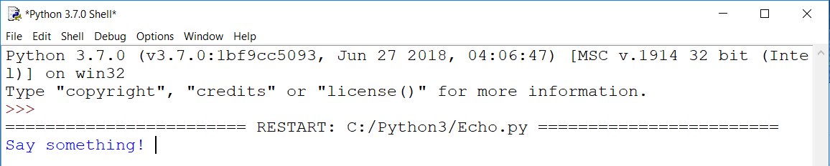

Type something and press enter to submit your input. You should see something like this in the python shell:

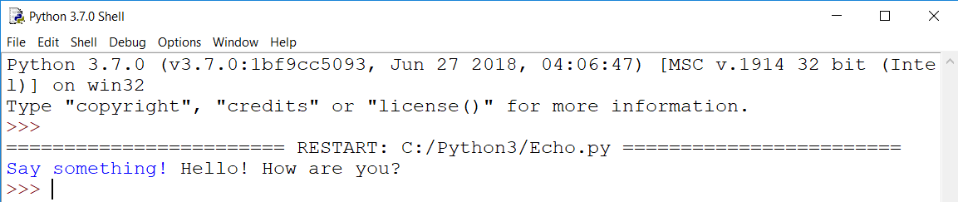

9. Now write three print statements that repeat what the user says back to them using .upper(), .lower(), and .swapcase().

10. Hit the keyboard key ***F5*** to run your **Python** script! And don't forget to SAVE your file!

Your program should look like this in the shell when you run it: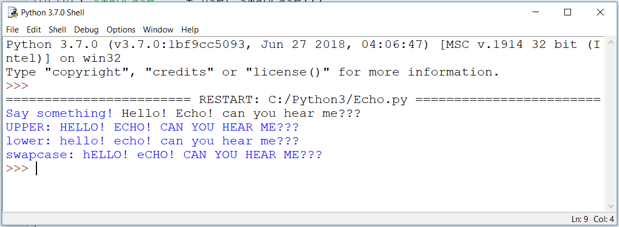

11. Save everything using endlab.

## 

## Bonus: Age Difference Calculator

**The purpose of this calculator is to take the input of two individuals’ age and to calculate their difference in age.**

1. Open your terminal and type startlab. In the text editor that opens, go to File -> New File and then File -> Save As…. Name your file AgeCompareCalculator.py. Make sure you are not in the shell!

2. Make a variable for the first person that takes input from the user. Such as

person_one = input(“What is the age of the first person? ”)

3. Repeat the same process to get an age for the second person.

4. Now you must find a way to compare these two variables. Hint, the variables store the user inputs as strings. What datatype should you use to make calculations? Remember how to convert datatypes?

5. Now that you have converted the datatypes of these variables, compare them using a mathematical operator to find the difference between the two ages. Store this difference as the variable age_difference.

6. This variable may be either positive or negative. Python has a function called abs(). Can you guess what it does? (Hint: The shell is great for testing short lines of code!)

7. Finally, in order for the user to see the age, you need to find a way to display it! Do you remember how Python displays output?

8. Run endlab to save your file to Github.